|  |
| --- |
| **Church News**  radiYAte Weekend Away  Young adults weekend away is happening Sept 14-16! Our speaker is James Chen. Registrations still open!  FRESH in August  We'll be running 5 weeks of supper and dialogue for our non-Christian friends starting August 8 in Kingsgrove. Think about whether you'd like to come and who you can invite. To help us prepare for it, and to get an idea of its format, we're running ‘PRE-FRESH' on Wed August 1 at 7.30pm in the hall.  Support Gospel work at SWEC!  Generous financial partners are needed to help grow the ministry of Gospel work at SWEC.  Please consider partnering with SWEC by setting up electronic giving.  For information on how to set this up, email [give@swec.org.au](mailto:give@swec.org.au)  Community Groups  Want to know how your faith in Jesus interacts with your everyday life? Community groups are a great place to help you think through this. Meeting throughout the week on a regular basis, community groups are a great opportunity to help make sense of what it means to be a believer of Jesus in this world. For more information please email [communitygroups@swec.org.au](mailto:community@swec.org.au) |

|  |  |  |  |  |  |  |  |
| --- | --- | --- | --- | --- | --- | --- | --- |
| **Upcoming Events**  July  18 – Combined Prayer and Worship Night (7.45pm Kingsgrove)  August  1st - Pre-FRESH (7.30pm Kingsgrove hall)  5th – Congregational Prayer Meetings (10am and 3pm)  8th – FRESH begins (Every Wed for 5 weeks, 7.30pm Kingsgrove)  18th – RICE Rally | **Stay Connected**   |  |  | | --- | --- | |  | fb.com/swechurch | |  | @swechurch | |  | swec.org.au/newsletter | |

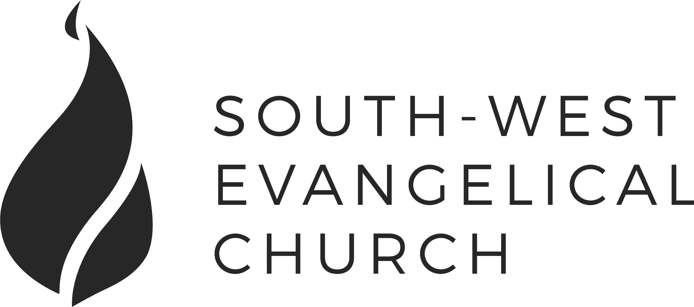

Sunday, 1 July 2018 | 11am English | [www.swec.org.au](http://www.swec.org.au)

Pastor Peter Ko | 0433 493 488 | pko@swec.org.au

What we’ll be doing during our time together

1. Worship

We’ll be worshipping God through song, prayer and by hearing His word.

Today’s confession prayer

Almighty and most merciful Father,  
You have loved us with an everlasting love,  
But we have gone our own way  
And have rejected you in thought, word, and deed.  
We are sorry for our sins  
And turn away from them  
For the sake of your Son who died for us,  
Forgive us, cleanse us and change us.  
By your Holy Spirit, enable us to live for you,  
And to please you more and more;  
Through Jesus Christ our Lord.  
Amen.

Bible reading -

2. Community

An opportunity to get updated with what’s happening at SWEC!

3. Prayer

We’ll be praying for various needs in our church, the wider community, and the world.

4. God’s Word

Today’s sermon will be given by Peter Ko.

5. Response

An opportunity for us to respond by singing, through holy communion, and by financial giving.

6. Blessing & Sending  
Go with God’s blessing to love and serve him and the world.

|  |  |  |
| --- | --- | --- |
| **Pastors**  Peter Ko (Lead Pastor)  Stephen Fei  Dom Cheung  Karen Ko | **Elders**  Johnson Lee  Andrew Lim  Kirby Wong  Nelson Siu  board@swec.org.au | **Student Pastors**  Andrew Hayes  James Hoey  **Ministry Intern**  Lisa Truong |

Compassion Sunday

Luke 10:25-37

Introduction

1. The Big Two

2. Who Is My Neighbour?

a. The Parable

b. The ‘Other’

c. The Twist

d. The Answer

3. No Ordinary Love

a. Fear

b. Overwhelmed

c. Don’t Know How

Today’s Sermon Code: **PGC**

Zacpages is a digital church tool to follow our sermon outlines, read bible references, take notes and find out more information about our upcoming church events.

Check it out on the Apple App Store, or Google Play Store!

